Context based Human LanguageAI-Controlled Mecanum Wheeled Robot for Automated Tool Transportation in Assembly Lines
¹S.Pavithra ,² Omkar Aditya Sahoo, ³Dakshesh Gaur, ⁴ Samartha

^{1,2,3,4} School of Computer Science and Engineering
Vandalur-Kelambakkam road, Chennai, India, 6000127
pavithra.sekar@vit.ac.in, omkaraditya.sahoo2021@vitstudent.ac.in, dakshesh.gaur2021@vitstudent.ac.in, samartha.2021@vitstudent.ac.in

Corresponding author: Dr.S.Pavithra (e-mail: pavithra.sekar@vit.ac.in)

ABSTRACT
This work presents a novel approach to controlling an omnidirectional robot with Mecanum wheels using a dual-input system: natural language AI commands and a manual joystick interface. This robot, which integrates Gemini AI, is designed to interpret complex linguistic instructions and execute precise movements omnidirectionally at specified angles and dynamically adjusting speed. Prompt engineering techniques have been applied to refine the language input process, ensuring that AI commands yield accurate, context-aware actions by enhancing the AI's understanding and responsiveness to complex directives. This dual-control functionality enables both autonomous and manual operations, enhancing flexibility for various applications. Additionally, the robot's movements are simulated in real-time using a ROS package, providing a synchronized virtual model that mirrors physical navigation, allowing for safe testing and predictive control. The robot autonomously tackles complex navigation tasks by selecting optimal paths and sources, guided by a contextual understanding of environmental and task requirements. This approach demonstrates the viability of combining AI-driven decision-making with advanced mobility and user-friendly control in robotics, while also showcasing the role of prompt engineering in achieving reliable, responsive AI control. This project offers insights for future advancements in intelligent, adaptable robotic systems, emphasizing the practical integration of AI and flexible control mechanisms.
INDEX TERMS: Mecanum wheels, omnidirectional robot,Gazebo simulation, joystick control,Gemini AI.

I. INTRODUCTION

Robots designed for autonomous navigation encounter significant challenges when operating in complex environments, particularly those that demand precision and adaptability in confined or obstacle-rich spaces. This project addresses these challenges by developing a robotics solution equipped with Mecanum wheels, which enable omnidirectional movement, allowing the robot to traverse smoothly in any direction without the need for reorientation. This unique capability enhances the robot's mobility and agility, making it particularly advantageous in tight or dynamic settings where conventional wheels fall short [6], [8], [28].

Central to this project is the integration of Gemini AI, which empowers the robot to interpret and execute complex natural language prompts. This AI-driven approach allows for intuitive control, enabling operators to issue intricate commands related to navigation and speed adjustments, further enhancing the robot's operational flexibility. The Robot Operating System (ROS) provides a robust framework that facilitates real-time control and seamless integration of these AI-driven commands, optimizing the robot's movement management in unpredictable environments [5], [10], [22].Additionally, the Gazebo simulation platform offers a realistic virtual environment for testing and refining the robot's performance. It enables controlled evaluation of its navigation capabilities across varied terrains while mirroring the effects of AI commands in real-time [18-19].

A user-friendly control interface has been developed, allowing operators to monitor the robot’s status, modify parameters, and issue commands effortlessly. This interface bridges the gap between simulation and practical operation, ensuring users retain oversight in both virtual and real-world scenarios [16], [21], [24].By combining Mecanum wheels, AI-driven command execution, ROS-based control, and simulation tools like Gazebo, this project presents a versatile robotic platform designed to tackle complex navigational tasks with precision. The integration of AI prompts highlights the potential for creating adaptable solutions that enhance the robot's responsiveness in challenging environments [6], [9], [20].
II. RELATED WORK

- Omni-Directional Mobility Platforms and Control Systems
The advent of omni-directional mobility platforms has revolutionized applications in various industries, particularly in intelligent factories and warehouse logistics. A novel mobility platform has been proposed to enhance transportation capabilities, featuring an innovative power train structure that integrates drive and suspension modules. This design enhances load capacity and enables movement in any direction, accommodating varying sizes of load objects effectively. Sensor fusion algorithms leveraging low-cost sensors are employed to estimate the platform's position accurately, enhancing its human interaction features, particularly the intuitive one-hand maneuvering capability. Experimental results demonstrate the efficacy of these algorithms in executing precise path-following, accurate position measurement, and effective user manipulation tests[22].
Further advancements in autonomous mobile robots (AMRs) have led to the development of small, omni-directional robots equipped with infrared thermal sensors, geomagnetic sensors, and ranging sensors to monitor and follow individuals in indoor environments [24]. This robotic system leverages omni-wheels for movement, allowing navigation through tight spaces. The integration of geomagnetic sensors facilitates posture control, while the infrared sensors enable human temperature measurement, forming a basis for robust human-tracking control methods defined by specific operational modes based on object proximity[29].
- Motion Planning in Autonomous Systems
The necessity for effective motion planning in dynamic environments has been thoroughly explored, particularly for car-like autonomous mobile robots facing dynamic obstacles. The study introduces a hybrid motion planning algorithm, TEB-CA (Timed Elastic Band-Collision Avoidance), which enhances the capabilities of traditional motion planning methods by incorporating collision avoidance models [18]. This innovative approach integrates jerk, smoothness, and curvature constraints to optimize path execution, demonstrating superior performance in simulations and real-world tests, thus ensuring safe navigation amid moving obstacles [3].
In the realm of multiple wheeled mobile robots (MWMRs), a novel distance- and velocity-based simultaneous obstacle avoidance and target tracking method (DV-SOATT) is presented. This method incorporates relative positions and velocities of both the robots and obstacles, minimizing unnecessary collision avoidance maneuvers. By introducing auxiliary velocity terms, the DV-SOATT enhances trajectory tracking efficiency while maintaining stability through a well-defined control law built on Lagrange multipliers. This method's efficiency is validated through extensive physical experiments and simulations, illustrating its practical applicability [12].
- Communication and Resource Optimization in Autonomous Networks
The optimization of data transmission within autonomous vehicular networks (AVNs) is pivotal for enhancing collaborative driving capabilities. This study models the ROS (Robot Operating System)-based publish/subscribe communication framework, addressing the inherent challenges of resource allocation amidst multiple data flows and potential link conflicts [17]. By leveraging Lyapunov optimization techniques, the paper presents a systematic approach to optimize power allocation and ensure conflict-free data transmission. The proposed method significantly reduces resource wastage and enhances communication efficiency in2 dynamic, bandwidth-constrained environments[11].
D.Advancements in Mecanum Wheel Technology
The exploration of Mecanum wheel technology has underscored its utility in constructing autonomous mobile robots capable of navigating complex terrains. Research focusing on the kinematic and dynamic modelling of four Mecanum wheel mobile robots has revealed essential insights into their behaviour on inclined surfaces. By employing Lagrange’s equations, the dynamic model considers gravitational influences, facilitating simulations that illustrate how terrain slope affects robot trajectory and stability [6]. Moreover, a Model Predictive Control (MPC) algorithm has been developed to enhance trajectory tracking accuracy in Mecanum wheel automated guided vehicles (AGVs) under challenging conditions. This innovative approach incorporates a linear error model for predictive control, demonstrating significant improvements in both tracking performance and computational efficiency [8].
E. Personalized Mobility Solutions in Assistive Robotics
In addressing the mobility challenges faced by the elderly and individuals with chronic conditions, the WANDER project introduces a novel omni-directional exo-robot that provides personalized support for walking assistance. This exo-robot employs a variable admittance controller, allowing it to adapt to user-specific needs and preferences effectively. Through experimental trials, the system has been shown to enhance user comfort and reduce energy expenditure, highlighting the importance of customization in assistive technologies for promoting mobility [14].

III. Methodology

The system architecture combines mecanum wheels for smooth, omnidirectional movement in tight spaces with dual control modes for AI-driven autonomy and manual joystick control. Integrated with ROS, the architecture supports real-time simulation and efficient development (as depicted in Fig. 1), making it ideal for warehouse automation and navigation in confined environments.

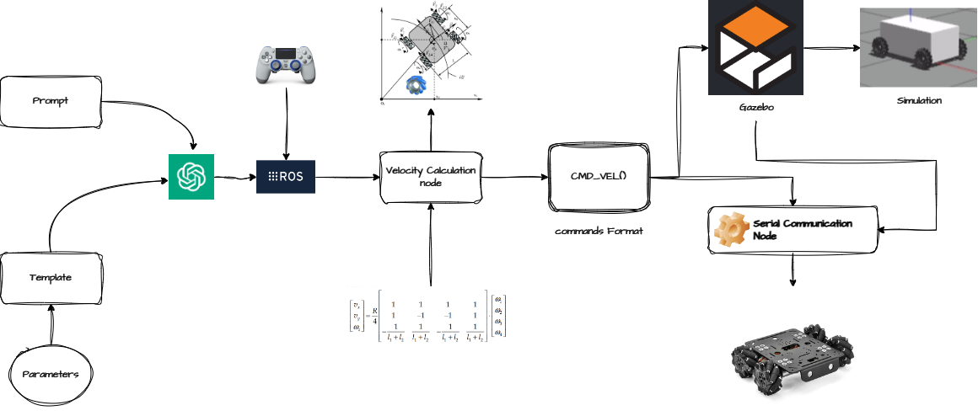
FIGURE 1. Complete System architecture of the AI Driven Autonomous Omni Directional Mechanum Wheeled Robot

Robot Hardware:
This project involves developing and controlling a mecanum-wheeled omnidirectional robot using ROS (Robot Operating System). The robot is designed to navigate tricky and difficult terrains effectively. The methodology encompasses several key components: ROS node management, AI command integration, joystick control, Arduino Nano microcontrollerinterfacing, Gazebo simulation, and additional methods for ensuring robust performance.
Robot Design and Mecanum Wheels:
The robot will be equipped with mecanum wheels, allowing for omnidirectional movement. The hardware assembly involves mounting the wheels, attaching motors with proper alignment. Each mecanum wheel will be driven by individual motors, which are controlled through motor drivers interfaced with an Arduino Nano microcontroller. This setup ensures precise control over the motors for effective maneuverability(as illustrated in Fig. 2).
Robot Operating System (ROS) Setup:
ROS 1 is installed on the onboard computer. The choice of ROS version (e.g., ROS Noetic) is based on compatibility with the hardware and software requirements.A ROS workspace is set up with appropriate directories for nodes, packages, and configuration files.
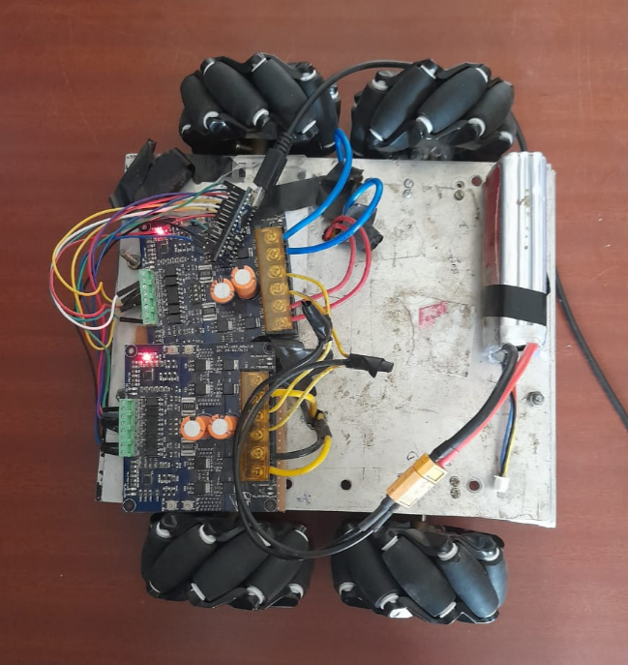
FIGURE 2. Top View of the Omni-directional Bot
ROS Node Management:
Publisher Node:A ROS node is developed to publish sensor data, such as encoder readings and IMU data, to relevant topics. This node also converts sensor data into a format suitable for control algorithms, enabling accurate feedback for the robot's movement.
Subscriber Node:Another ROS node subscribes to control commands and navigation instructions, processing input from the joystick and generating motor commands (depicted in Fig. 3). This node interprets commands for precise movement control, smooth and coordinated navigation in various operational scenarios.

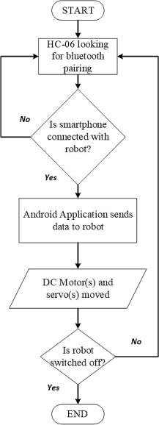

FIGURE 3. Complete Node Structure of the ROS Environment
Communication
Topics and Messages: Necessary ROS topics and messages for communication between nodes are defined. Topics for motor commands, sensor data, and control feedback are established to ensure efficient communication. Additionally, the system incorporates a robust error handling mechanism to enhance reliability and responsiveness during operations.
Input Integration
AI Command Integration: The speed of the robot is controlled by integrating both joystick inputs and AI-generated commands. When using the joystick, operators can adjust the robot's speed directly through throttle variations, affecting linear velocities (x, y) and angular velocity (z) to control motor output. This approach gives users precise manual control over the robot's movement.
For AI command integration, the Gemini model interprets high-level movement instructions to generate specific velocities for x, y, and angular directions. Here, the formula

$E_{q(z|x)}\left[\log{p\left(x | z\right)}\right]=\int{q\left(z | x\right)\log{p\left(x | z\right)}dz}$(1)

is relevant, as it represents the expected log-likelihood of a model’s predicted movements based on latent variables. From Eq. 1, E is expected value and q(z∣x) refers to an approximate posterior distribution over the latent variable z given the observed data z. This helps in ensuring that the AI-generated commands are aligned with the desired motion, providing a probabilistic framework for accurate command translation. By optimizing this expectation, the model adapts its outputs to achieve smooth and reliable navigation across various terrains.
In the case of AI command integration, the Gemini model processes high-level movement instructions that include desired speeds and directions. It generates specific linear velocities for the x and y axes, as well as the angular velocity, based on the interpreted commands. This system allows for dynamic adjustments to the robot's motion, ensuring it can navigate effectively through various terrains.
Moreover, the AI can also calculate the appropriate duration for each movement by assessing the distances to be covered and the specified velocities. By factoring in these parameters, the AI generates precise commands that dictate not only how fast the robot should move but also when to change its speed or direction, thus optimizing its travel time while maintaining stability and control .Figure 4 shows the complete working of the LLM model. The similarities between the prompts and the texts stored in the vector database are calculated based on the cosine similarity between the prompt embedding vector (q) and document chunk embeddings (d) as calculated below:
$cosine_similarity(q,d)$=​$\frac{q.d}{\left|q\right|.|d|}$(2)
JoyNode Configuration: The joy package in ROS is utilized to interface with the joystick controller. The joy_node is configured to handle input from the joystick, mapping it to robot control commands.
Mapping Controls: A configuration file is developed to map joystick inputs (e.g., throttle, steering) to robot movement commands. Sensitivity and dead zones are adjusted as necessary for smooth control.
Control Algorithm:
A control algorithm is implemented to translate joystick inputs and AI commands into movement commands for the mecanum wheels.
Mechanum wheel Velocity Calculation
A 4x3 matrix defines the relationship between wheel velocities and the robot's linear and angular velocities (cmd_vel). The algorithm computes individual wheel velocities (fr, fl, rr, rl) based on linear x, y, and angular z velocities using matrix dot product.
$\left[\begin{matrix}1 & 1 & (wfr+lfr) \\ 1 & -1 & -(wfl+lfl) \\ 1 & -1 & (wrr+lrr) \\ 1 & 1 & -(wrl+lrl)\end{matrix}\right] × \left[\begin{matrix}vx \\ vy \\ vz\end{matrix}\right]$= $\left[\begin{matrix}vfr \\ vfl \\ vrr \\ vrl\end{matrix}\right]$ (3)
vfr​ is the velocity of the front-right wheel,vfl​ is the velocity of the front-left wheel, vrr​ is the velocity of the rear-right wheel, vrl​ is the velocity of the rear-left wheel as in Eq. 3.

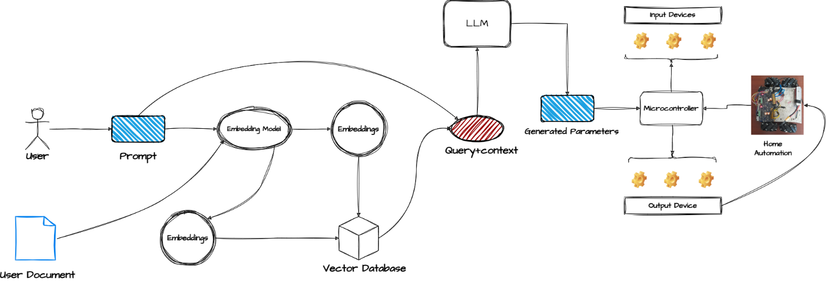
FIGURE 4. Complete System architecture of Retrieval-Augmented Generation process for query interpretation

IV. EXPERIMENTAL RESULT
Gazebo Simulation
Model Creation:A detailed 3D model of the robot is created, including mecanum wheels, using URDF (Unified Robot Description Format) or SDF (Simulation
Description Format) files. Sensors and actuators are included in the model.
Environment Design:Various terrains and obstacles are designed in Gazebo to simulate real-world scenarios, including uneven surfaces, inclines, and dynamic obstacles that the robot may encounter (as shown in Fig.5).



FIGURE 5. Environment Design for simulation

Simulation Execution:
Gazebo is used to run simulations and test the robot’s performance in different terrains. The robot’s behavior is monitored and control parameters are adjusted based on the simulation results (as shown in Fig. 6 and Fig. 7).
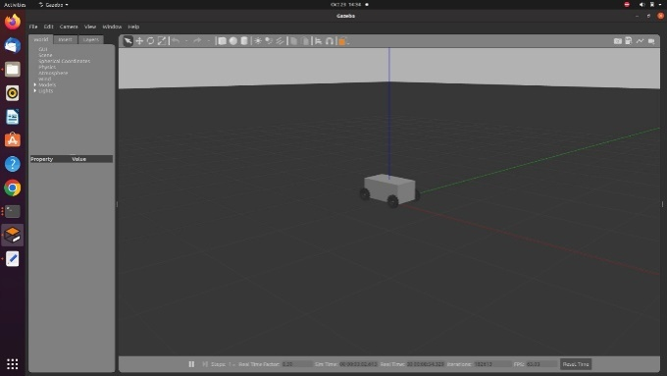
FIGURE 6. Simulation of Bot in Gazebo

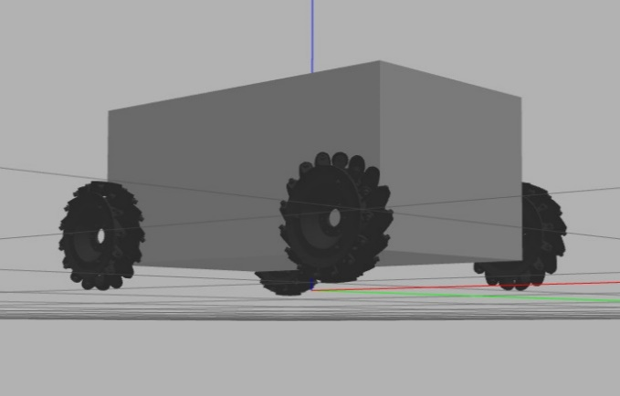
FIGURE 7. Structure of MechanumBot in Gazebo

The implementation of mecanum wheels in our robot resulted in highly flexible omnidirectional movement, overcoming limitations typical of traditional wheeled robots in confined spaces. Our dual-control system, combining autonomous AI-driven navigation with manual joystick control, provided operational versatility, allowing seamless adaptation to various tasks, particularly in warehouse automation scenarios. Through ROS-based simulation, we conducted concurrent testing and validation of navigation and algorithms, significantly streamlining the development process and reducing time for iterative improvements. In practical applications, the robot demonstrated efficient handling of tight aisles, reliable path optimization, and minimal manual intervention. This approach not only enhanced the robot's maneuverability and operational efficiency but also highlighted its potential in automating logistics processes in restricted environments.
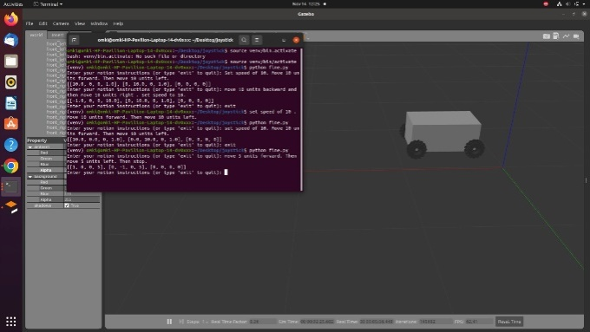
FIGURE 8. Structure of Mechanum Bot in Gazebo
In Figure 8, the user command dictates the bot to move “5 units forward and 5 units left”, hence the bot is observed to follow the coordinates generated by the Generative AI. This movement demonstrates the system’s ability to interpret and execute directional commands accurately through AI-generated path planning, ensuring precise navigation to the target location.
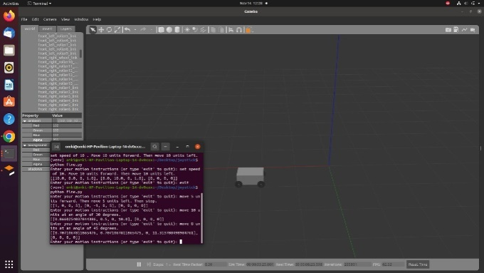
FIGURE 9. Structure of Mechanum Bot in Gazebo
In Figure 9, the user command dictates the bot to move “10 units forward at an angle of 30 degrees”, hence the bot is observed to follow the coordinates generated by the Generative AI.

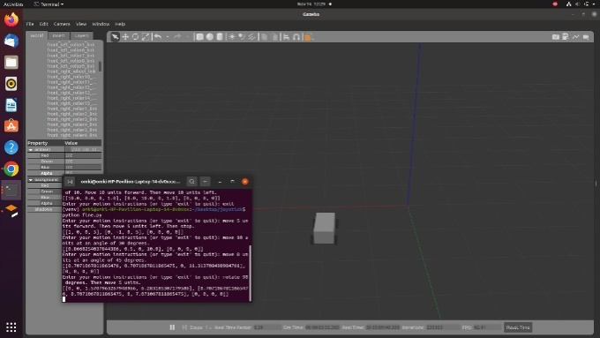
FIGURE 10. Structure of Mechanum Bot in Gazebo
In Figure 10, the user command dictates the bot to move “rotate 90 degrees”, hence the bot is observed to follow the coordinates generated by the Generative AI.

CONCLUSION
This proposed work successfully develops a mecanum-wheeled omnidirectional robot that excels in navigating challenging terrains with precision and flexibility. By leveraging advanced technologies such as the Robot Operating System (ROS), joystick control, AI command integration, and Gazebo simulation, we have effectively addressed the complexities associated with robotic navigation in real-world environments.
The exceptional maneuverability afforded by the mecanum wheels allows the robot to move in any direction without the need for physical reorientation, significantly enhancing its capability to overcome obstacles and navigate tight spaces that would pose challenges for traditional wheeled robots. The robust control system built within the ROS framework ensures real-time processing of sensor data, facilitating responsive and precise movements.
The critical role of Gazebo simulation in this project cannot be overstated. By enabling thorough testing of the robot's navigation algorithms in a controlled environment, we have minimized risks and costs associated with physical trials, leading to improvements in the robot's operational reliability
Additionally, the integration of joystick control has provided operators with intuitive and precise handling capabilities, allowing for seamless navigation in real-time. The incorporation of AI command integration further enhances the robot's adaptability by optimizing linear and angular velocity control and determining optimal travel durations based on high-level movement instructions. This innovative approach significantly improves the efficiency of navigation while also allowing for intelligent obstacle detection and path planning

CREDIT:
AUTHORSHIP CONTRIBUTION STATEMENT
Soumyajit Sen Sharma:Conceptualization, Data curation, Formal analysis, Investigation, Methodology-original draft.Omkar Aditya Sahoo:Conceptualization, Formal analysis, Investigation, Methodology, Project administration.Dakshesh Gaur:Resources, Software, Validation, Writing – original draft. Samartha:Quality Assurance, Documentation, Model Optimization and Performance Monitoring. S.Pavithra :Supervision,Visualization, Writing – review & editing.
Declaration of competing interest
The authors declare that they have no known competing financial interests or personal relationships that could have appeared to influence the work reported in this paper.
REFERENCES
- D. D, R. K R, S. R. K R, M. P G and G. M, "An Omni-Directional Self driving Robot for Indoor Surveillance," 2024 International Conference on Signal Processing, Computation, Electronics, Power and Telecommunication (IConSCEPT), Karaikal, India, 2024
- M. Niemeyer, J. Arkenau, S. Pütz and J. Hertzberg, "Streamlined Acquisition of Large Sensor Data for Autonomous Mobile Robots to Enable Efficient Creation and Analysis of Datasets," 2024 IEEE International Conference on Robotics and Automation (ICRA), Yokohama, Japan, 2024
- Z. Wang, P. Li, Q. Li, Z. Wang and Z. Li, "Motion Planning Method for Car-Like Autonomous Mobile Robots in Dynamic
Obstacle Environments," in IEEE Access, vol. 11, pp. 137387-137400, 2023
- R. Liu et al., "ROS-Based Collaborative Driving Framework in Autonomous Vehicular Networks," in IEEE Transactions on Vehicular Technology, vol. 72, no. 6, pp. 6987-6999, June 2023
- K. V. Ignatiev, M. M. Kopichev and A. V. Putov, "Autonomous omni-wheeled mobile robots," 2016 2nd International Conference on Industrial Engineering, Applications and Manufacturing (ICIEAM), Chelyabinsk, Russia, 2020, pp. 1-4
- C. Chaichumporn et al., "The Dynamical Modeling of Four Mecanum Wheel Mobile Robot on Typical Unstructured Terrain," 2024 21st International Conference on Electrical Engineering/Electronics, Computer, Telecommunications and Information Technology (ECTI-CON), Khon Kaen, Thailand, 2024, pp. 1-5
- S. Li, J. Zhang and S. Gu, "Discrete Time Trajectory Tracking Control for Four-Mecanum-Wheeled Mobile Vehicle: An Variable Gain ADRC Method," in IEEE Robotics and Automation Letters, vol. 9, no. 9, pp. 7771-7778, Sept. 2024
- M. Tang, S. Lin and Y. Luo, "Mecanum Wheel AGV Trajectory Tracking Control Based on Efficient MPC Algorithm," in IEEE Access, vol. 12, pp. 13763-13772, 2024
- H. Li, Y. Bu, Y. Bu, S. Mao, Y. Guan and H. Zhu, "Design and Control of a Transformable Multi-Mode Mobile Robot," in IEEE Robotics and Automation Letters, vol. 9, no. 2, pp. 1302-1309, Feb. 2024
- S. Wu, H. Luo, Y. Jiang, J. Zhang, J. Tian and S. Yin, "SIR-Aided Secure Transmission and Attack Detection for Security Management of Nonlinear Cyber-Physical System Using GRU Autoencoder," in IEEE Transactions on Industrial Informatics, vol. 20, no. 4, pp. 5529-5538, April 2024
- X. Li, Z. Xu, Z. Su, H. Wang and S. Li, "Distance- and Velocity-Based Simultaneous Obstacle Avoidance and Target Tracking for Multiple Wheeled Mobile Robots," in IEEE Transactions on Intelligent Transportation Systems, vol. 25, no. 2, pp. 1736-1748, Feb. 2024
- M. L. Elwin, B. Strong, R. A. Freeman and K. M. Lynch, "Human-Multirobot Collaborative Mobile Manipulation: The OmnidMocobots," in IEEE Robotics and Automation Letters, vol. 8, no. 1, pp. 376-383, Jan. 2023
- S. -H. Yun, J. Park, J. Seo and Y. -J. Kim, "Development of an Agile Omnidirectional Mobile Robot With GRF Compensated Wheel-leg Mechanisms for Human Environments," in IEEE Robotics and Automation Letters, vol. 6, no. 4, pp. 8301-8308, Oct. 2021
- A. Fortuna et al., "A Personalizable Controller for the Walking Assistive omNi-Directional Exo-Robot (WANDER)," 2024 IEEE International Conference on Robotics and Automation (ICRA), Yokohama, Japan, 2024
- N. Paykari, D. Lyons and M. Rahouti, "RoboStake: Pioneering Cooperative Navigation with a Novel Blockchain-Powered Proof-of-Stake in Robotic Teams," 2024 IEEE International Conference on Omni-layer Intelligent Systems (COINS), London, United Kingdom, 2024
- S. K. Gupta, W. Ahmad, D. A. Karras, A. Khang, C. K. Dixit and B. Haralayya, "Solving Roulette Wheel Selection Method using Swarm Intelligence for Trajectory Planning of Intelligent Systems," 2023 International Conference on Recent Trends in Electronics and Communication (ICRTEC), Mysore, India, 2023
- M. H. Rahman, S. Haque, M. F. A. Monir, M. F. Uddin and S. B. Alam, "Fabrication of a Revolutionary Pick-and-Place Robot with Omnidirectional Mobility," 2024 International Conference on Image Processing and Robotics (ICIPRoB), Colombo, Sri Lanka, 2024
- X. Li, Y. Zhou, R. Guo, X. Peng, Z. Zhou and H. Lu, "Spatio-Temporal Calibration for Omni-Directional Vehicle-Mounted Event Cameras," in IEEE Robotics and Automation Letters, vol. 9, no. 3, pp. 2311-2318, March 2024
- Q. -D. Hoang, L. A. Tuan, T. M. Thong, N. T. Gam, L. D. Nghiem and N. C. Cuong, "Kinematic-Based Nonlinear Control for an Omni-Directional Robot," 2023 International Conference on Control, Robotics and Informatics (ICCRI), Danang, Vietnam, 2023, pp. 30-33
- A. U. Darajat, U. Murdika and S. Sumadi, "Trajectory Tracking Control of Four Omni-wheels Robot using PID and Pole Placement State Feedback Controller for Telepresence Robot Applications," 2023 International Conference on Advanced Mechatronics, Intelligent Manufacture and Industrial Automation (ICAMIMIA), Surabaya, Indonesia, 2023, pp. 336-340
- B. Lakshmanaprakash and P. Rajalakshmy, "An IoT based autonomous outdoor patrol robot," International Conference on Computer Vision and Internet of Things 2023 (ICCVIoT'23), Coimbatore, India, 2023, pp. 127-132
- J. H. Choi and Y. Jin, "Development of an Omni-directional Human-friendly Mobility Platform for Industrial Warehouse," 2023 IEEE Transportation Electrification Conference and Expo, Asia-Pacific (ITEC Asia-Pacific), Chiang Mai, Thailand, 2023, pp. 1-4
- D. Hess, B. H. D. Trinh, M. Parys and C. Roehrig, "MobileRobot: Control of a Redundant Kinematic using Drive-Steering Modules for Mobile Manipulation," ISR Europe 2023; 56th International Symposium on Robotics, Stuttgart, Germany, 2023, pp. 176-183
- A. Andreev and K. Sutyrkina, "Motion Stabilization Control of an Omni-Directional Mobile Robot with Four Wheels," 2023 5th International Conference on Control Systems, Mathematical Modeling, Automation and Energy Efficiency (SUMMA), Lipetsk, Russian Federation, 2023, pp. 125-130
- M. Wang, Y. Su, H. Li, J. Li, J. Liang and H. Liu, "Aggregating Single-Wheeled Mobile Robots for Omnidirectional Movements," 2023 IEEE/RSJ International Conference on Intelligent Robots and Systems (IROS), Detroit, MI, USA, 2023, pp. 314-320
- F. N. Dermawan et al., "Goods Moving Robot Prototype Using 3-Wheel Omni-Wheel System," 2023 8th International Conference on Electrical, Electronics and Information Engineering (ICEEIE), Malang City, Indonesia, 2023, pp. 1-5
- A. Bhargava, A. S. Singholi and M. Suhaib, "A study on design and control of Omni-directional mecanum wheels based AGV system," 2023 14th International Conference on Computing Communication and Networking Technologies (ICCCNT), Delhi, India, 2023, pp. 1-6
- S. Mohamed, K. Kim, Y. Kim and B. Shin, "Design of a Quad Omni Wheeled Mobile Robot Using Linear Actuators," 2023 23rd International Conference on Control, Automation and Systems (ICCAS), Yeosu, Korea, Republic of, 2023, pp. 624-628
- T. Inoue and Y. Okazaki, "Human-Following Control of Omnidirectional Autonomous Mobile Robot by Integrating Sensor Information," 2023 23rd International Conference on Control, Automation and Systems (ICCAS), Yeosu, Korea, Republic of, 2023, pp. 1055-105.
- Auffarth, Generative AI with LangChain: Build large language model (LLM) apps with Python, ChatGPT, and other LLMs ,Packt Publishing, 2023.

